PDA Evidence - Chris Burn, G2 Cohort

Week 2:

Demonstrate the use of an array in a program. Take screenshots of:
*An array in a program
*A function that uses the array

Two Arrays or strings, pulled into “add_length_of_arrays” method
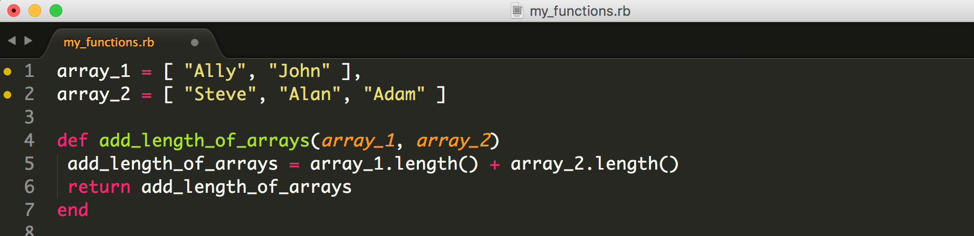

*The result of the function running

Shows TDD testing of method through MiniTest and result of MiniTest in Terminal...
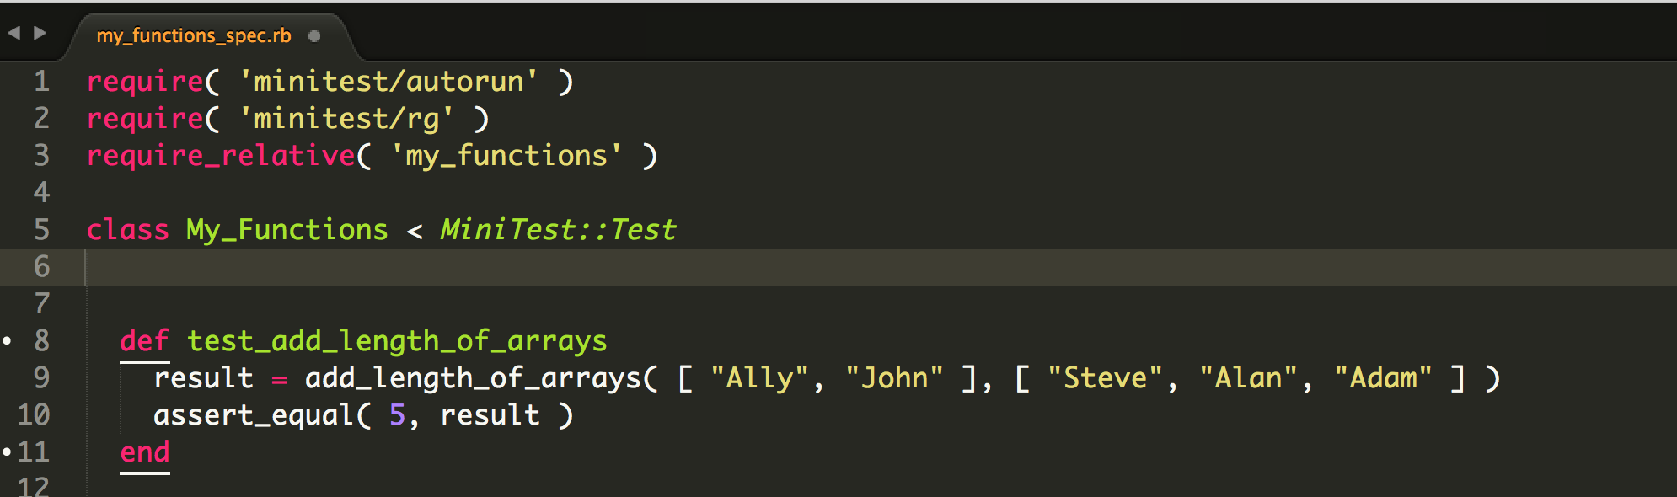

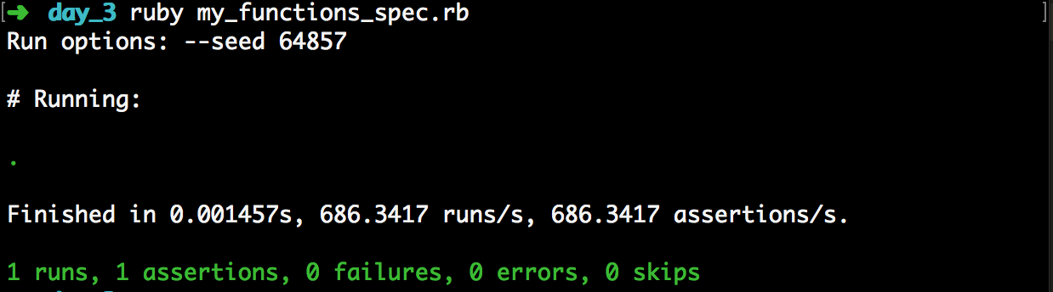
Demonstrate the use of a hash in a program. Take screenshots of:
*A hash in a program
WITH
*The result of the function running

Hash and an Array with in-built Hashes, WITH testing of function (separate) via MiniTest
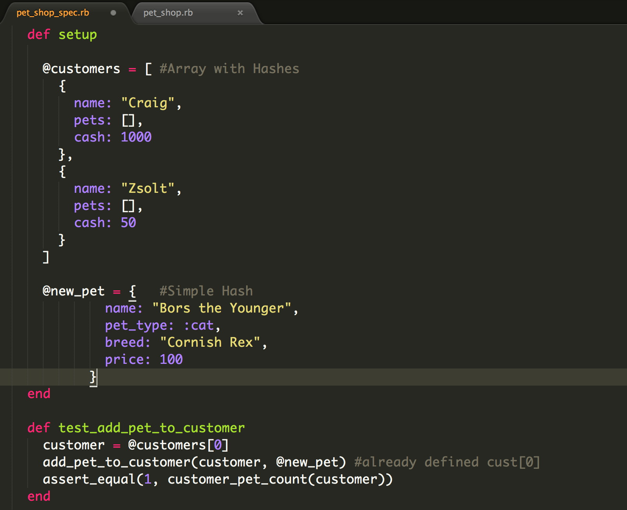

*A function that uses the hash
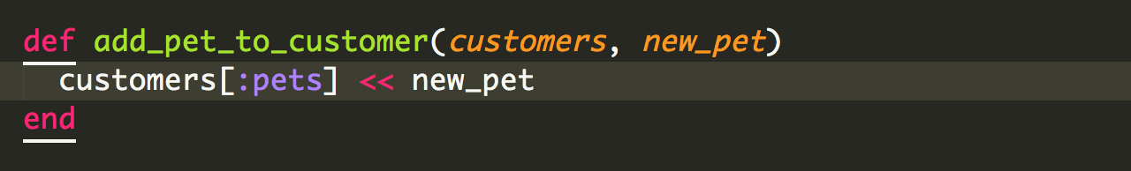

Week 3:

Demonstrate searching data in a program. Take screenshots of:
*Function that searches data

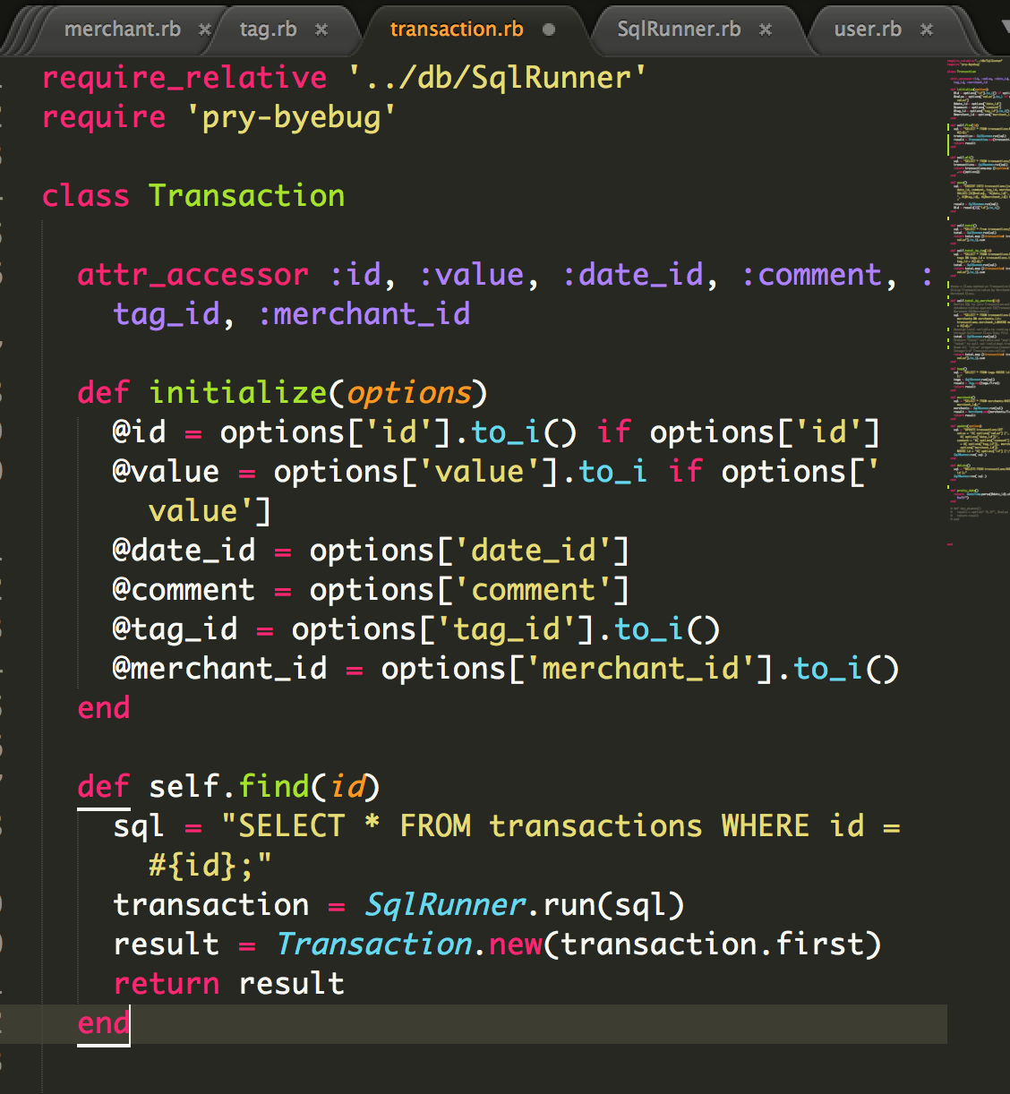

*The result of the function running
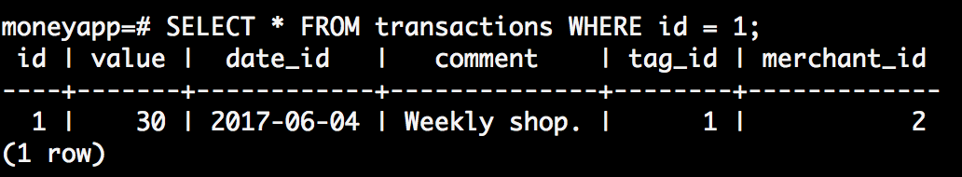

Demonstrate sorting data in a program. Take screenshots of:
*Function that sorts data

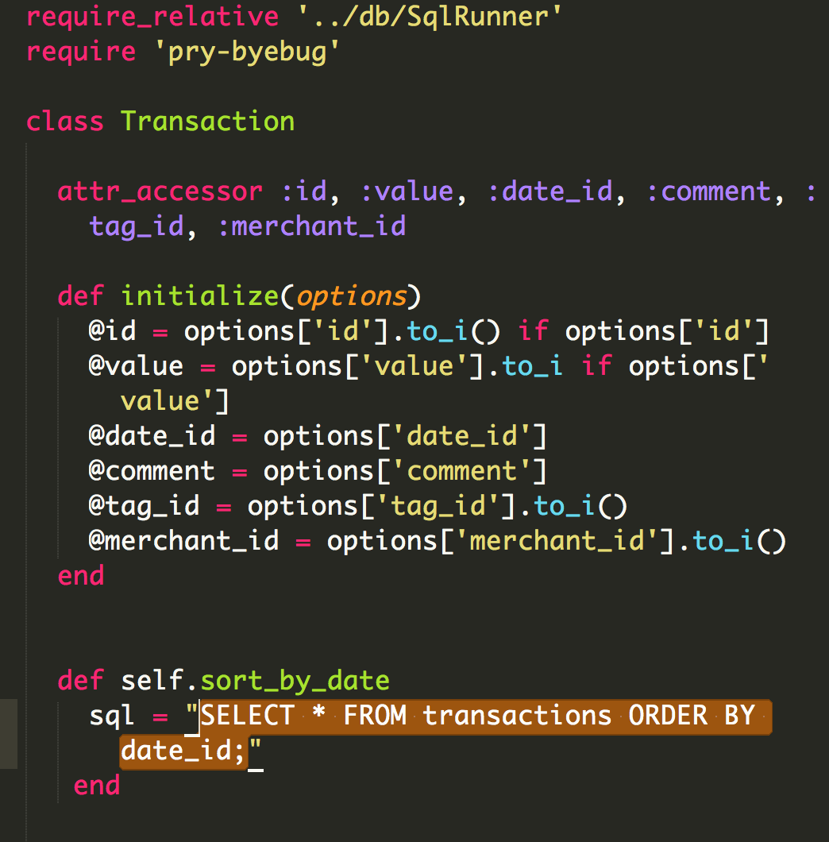

*The result of the function running

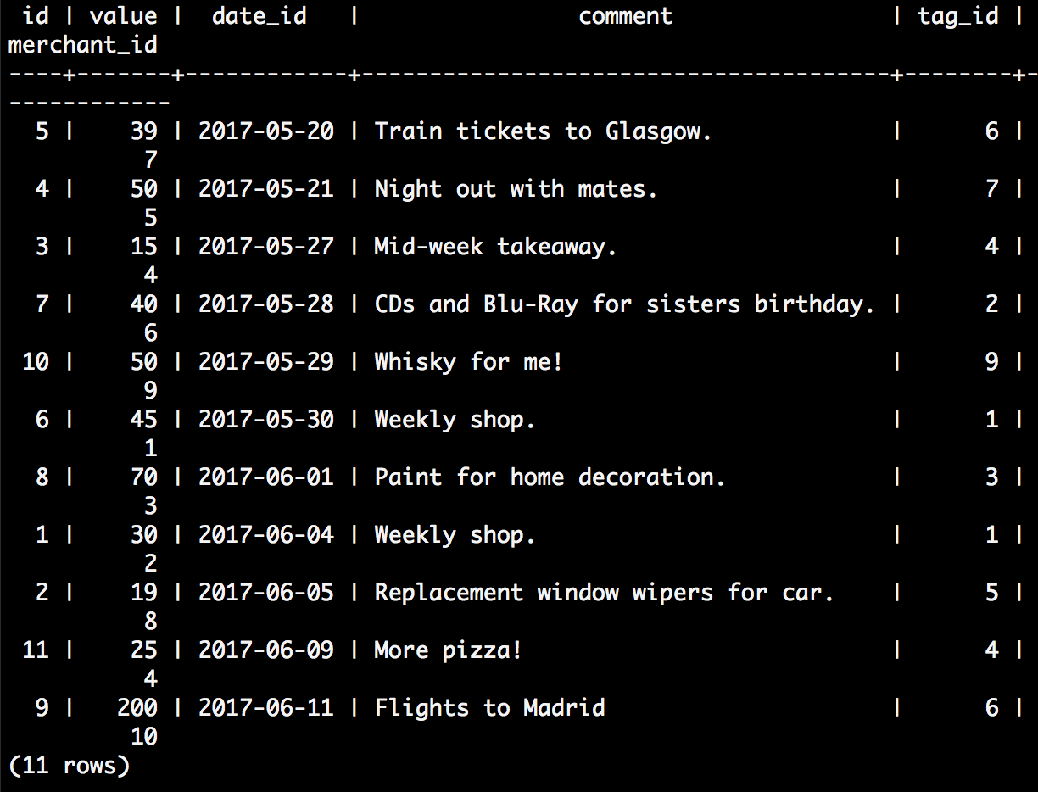
Week 5:

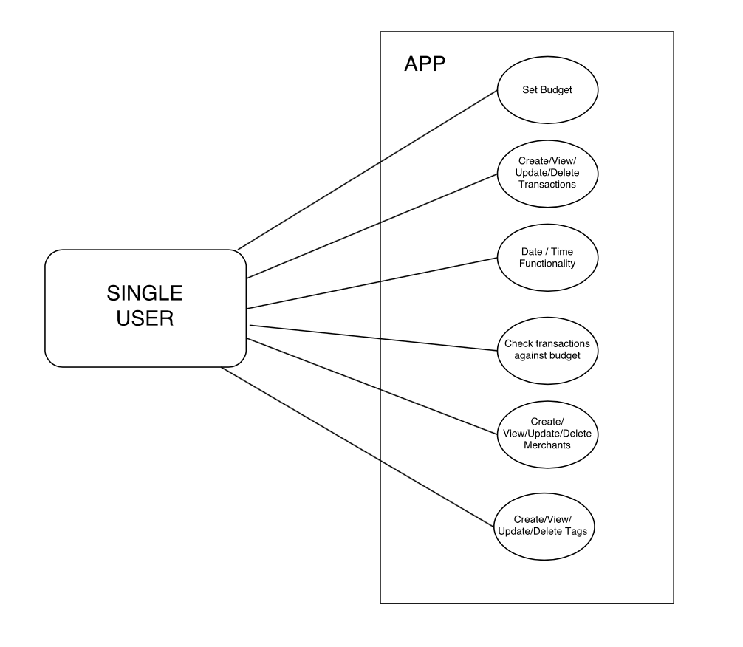

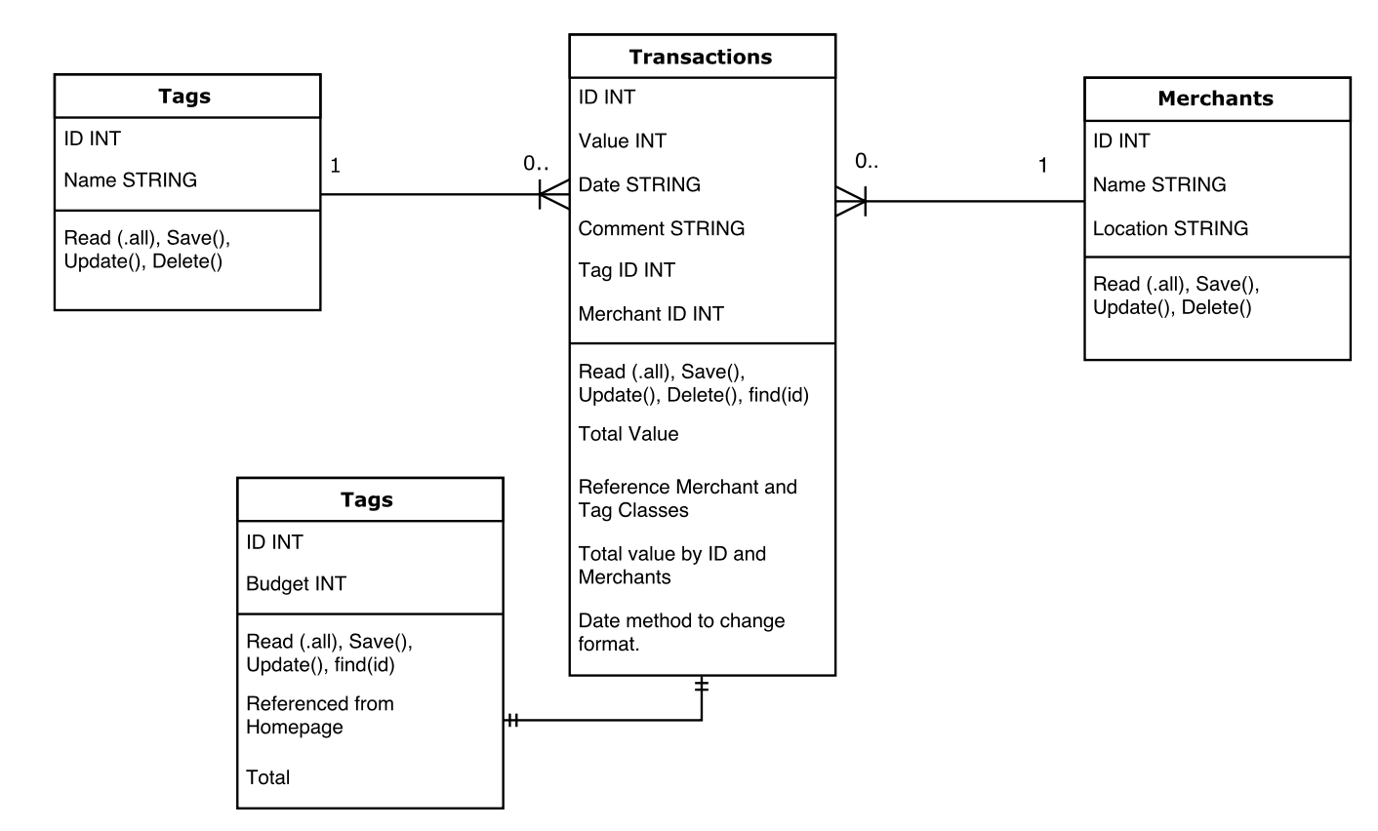

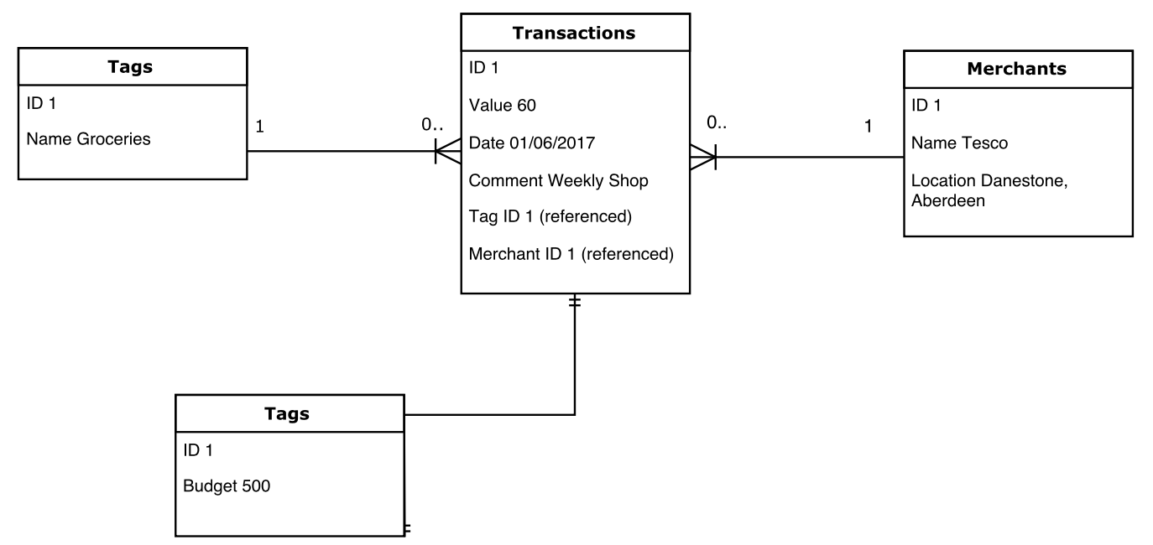

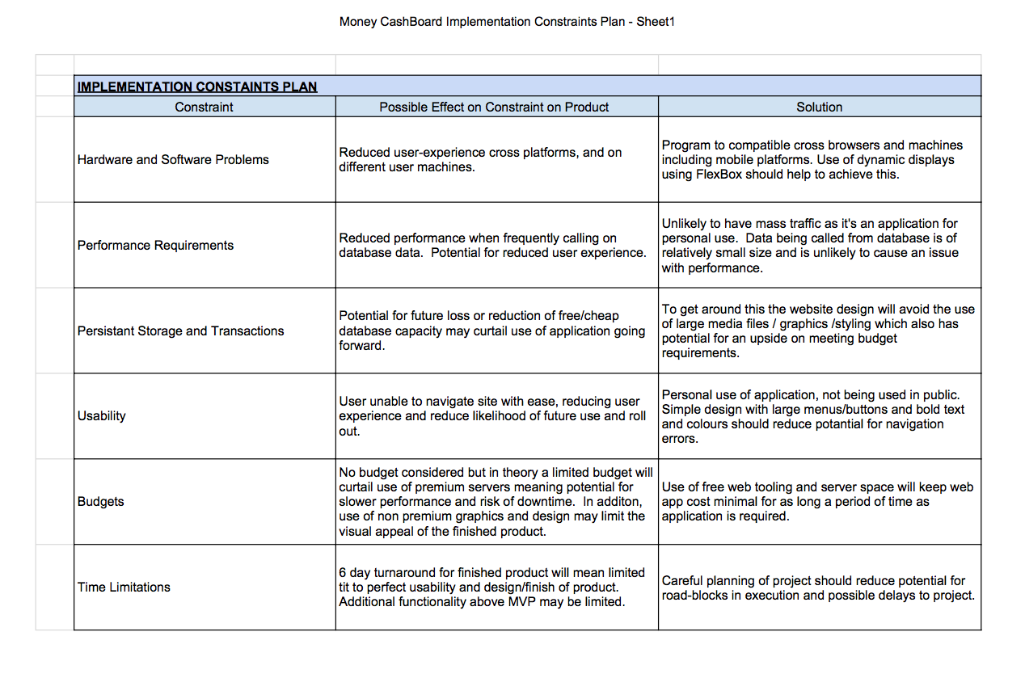

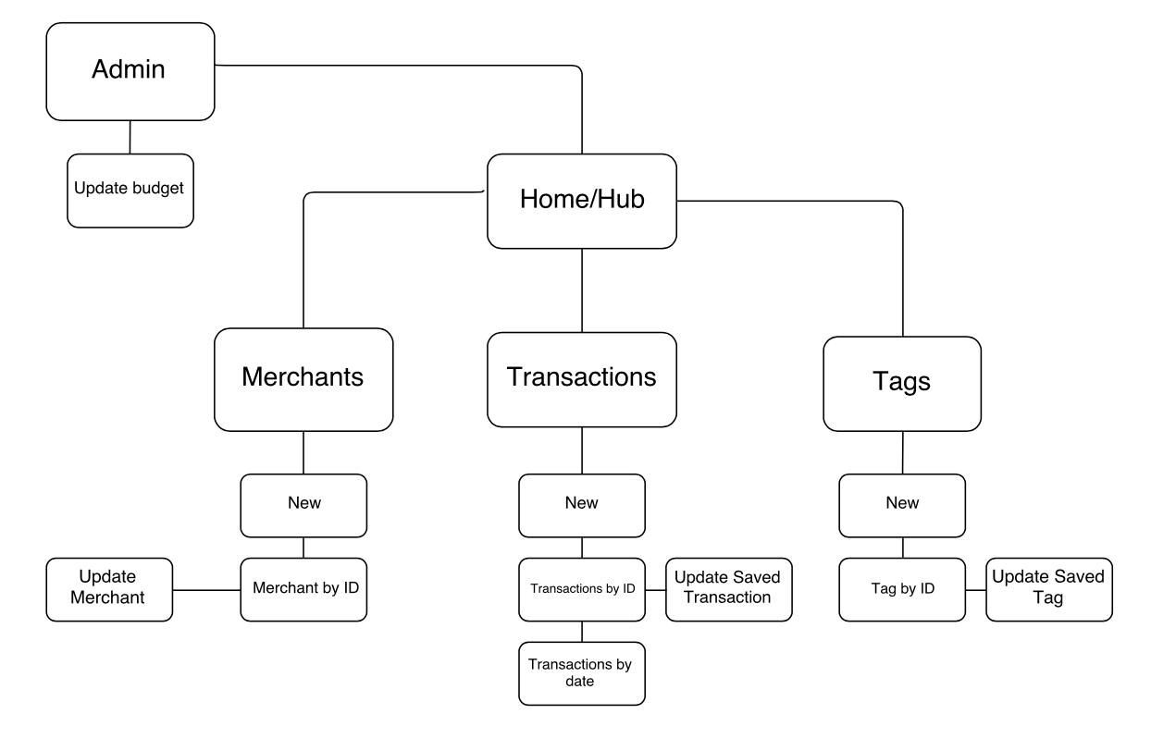

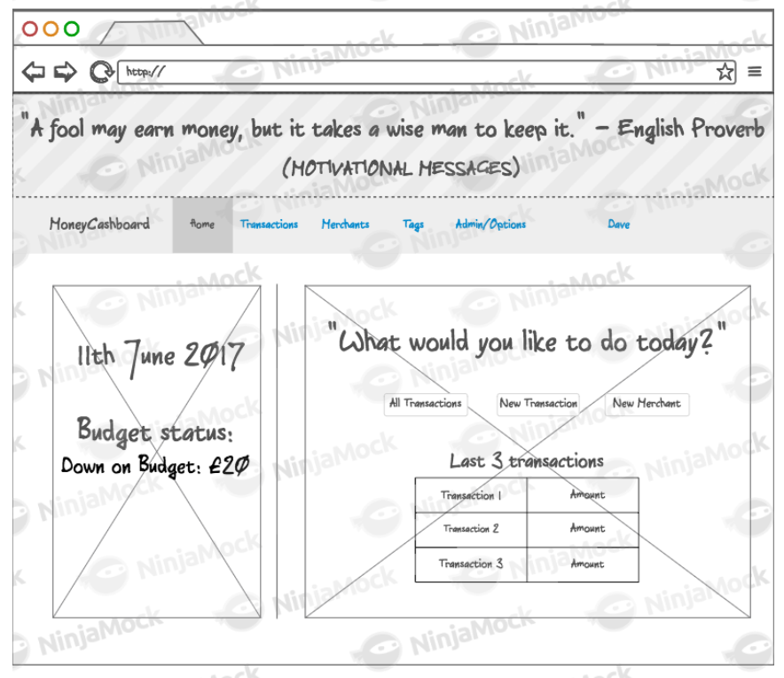
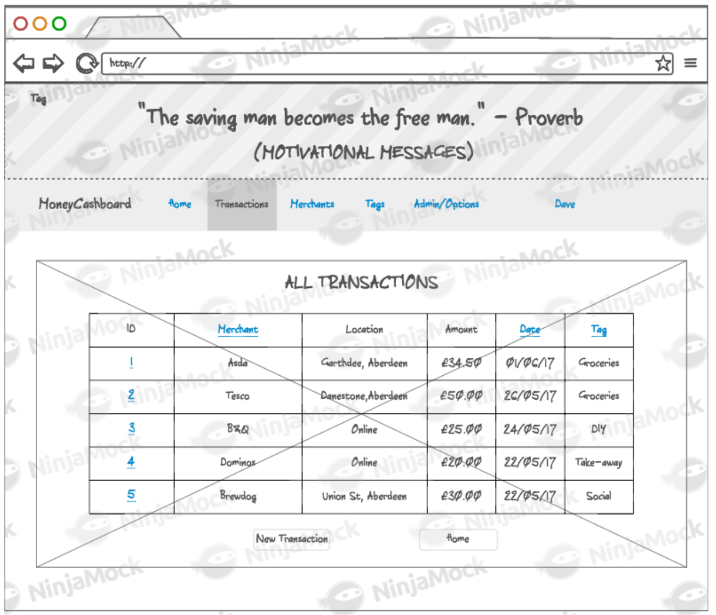

Psudo-code example showing a method calling on the result of an INNER JOIN on two database tables:
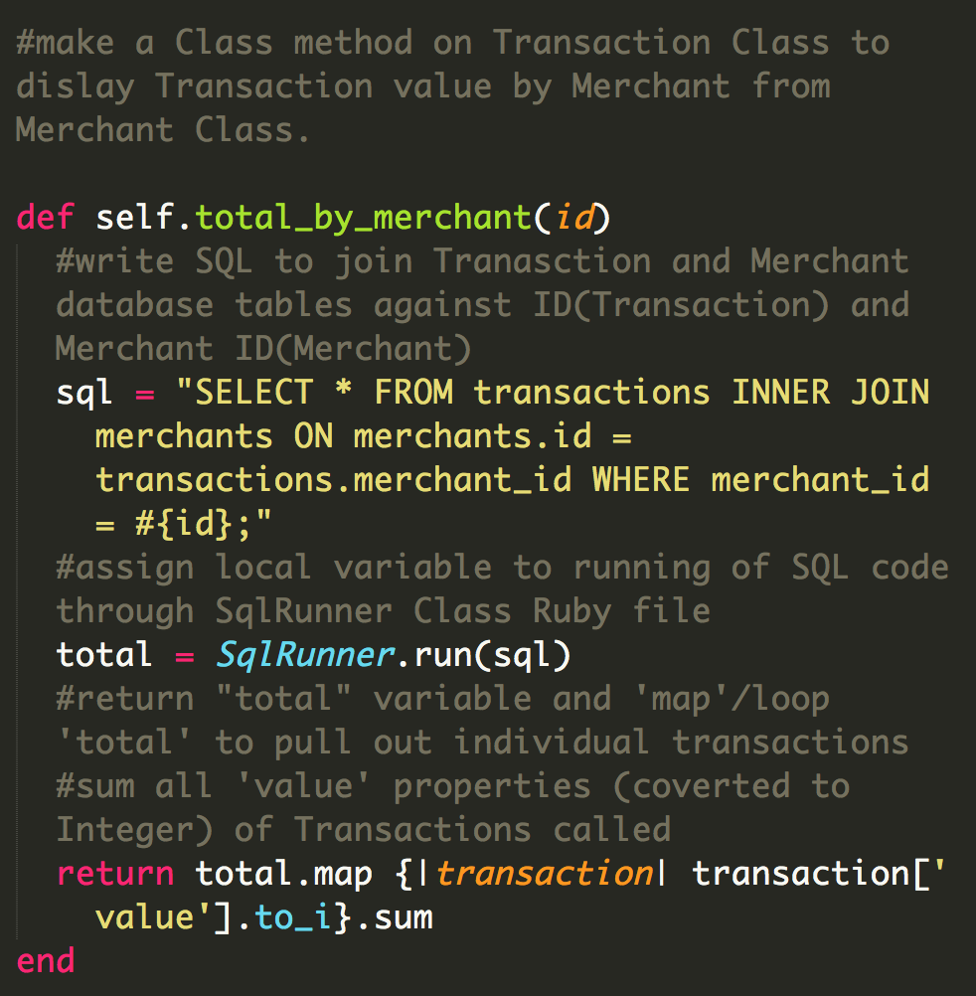
Show user input being processed according to design requirements. Take a screenshot of:
* The user inputting something into your program
* The user input being saved or used in some way

Show an interaction with data persistence. Take a screenshot of:
* Data being inputted into your program
* Confirmation of the data being saved

Show the correct output of results and feedback to user. Take a screenshot of:
* The user requesting information or an action to be performed
* The user request being processed correctly and demonstrated in the program



